- Early Christian Gatherings
“…the New Testament has little to say about the organization of the church. The Gospels record very few comments by Jesus on the subject, beyond acknowledging its existence, the need for leaders and its mission to spread the message. The Epistles give only the outlines of a model for how Christians are to meet, organize and appoint leaders. How then did the churches develop forms of organization? It appears that the churches borrowed from the society models that they considered compatible with their identity as Christians” (Jeffers, 71-72)

  - Mode and Location of Gathering

- first converts were Jews and Gentile sympathizers with Judaism (“god-fearers” Acts).

  - Acts 2:9-11

- synagogue was the first meeting place (Paul in Acts); format probably followed that of the synagogue

  - reading of scripture
  - prayer
  - singing
  - added: communion and baptism

- Christianity became separate from Judaism

- Roman “voluntary associations” (see Jeffers, 72-77)

    - “Somehow they managed to escape the notice of the authorities most of the time. One way they did this was to register as one of the kinds of associations allowed by Rome. This way they could legally meet, with the knowledge of the authorities and without scurrying around in the dead of night” (Jeffers, 73).

  - Professional associations
  - Religious associations
  - Burial associations
  - Household associations
- most early Christians met in the homes of a wealthier Christian family, or perhaps in the house of a patron

- NT
  - met in upper room (Acts 1:13; 2:2)

  - met in various houses in Jerusalem after Pentacost (Acts 2:46)

  - Saul entered “house after house” (Acts 8:3)

  - House of John Mark in Acts 12:12

  - house of Jason in Acts 17:5-9

  - The house of Priscilla and Aquilla served as a local church in various cities (1 Cor 16:19; Rom 16:3; Philem 2; Col 4:15

  - house of a slave’s master or patron

  - Rom 16 different “house churches.”

- Why houses?

  - Homes in that day were not very “homey”

  - Example: Roman “Insulae” (Apartment complex) (http://www.proxima-veritati.auckland.ac.nz/insula9/animation.html)

    - no running water, little ventilation, no bathroom facilities (use a pot), prone to collapse, fire, and the spread of sickness and disease.

      - read Jeffers 59-61

    - Where were the places where they would normally “do life”

- When did they meet in a “church building?”

  - Constantine?

  - Oldest church building discovered was found in Syria, in Dura-Europos dating back to AD 240; almost 100 years before Constantine.

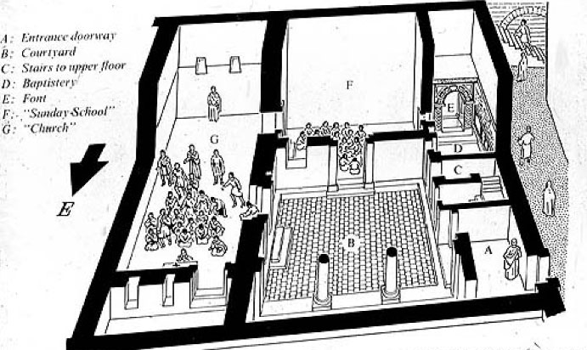
Figure 1 diagram of the church at Dura-Europos, AD 240

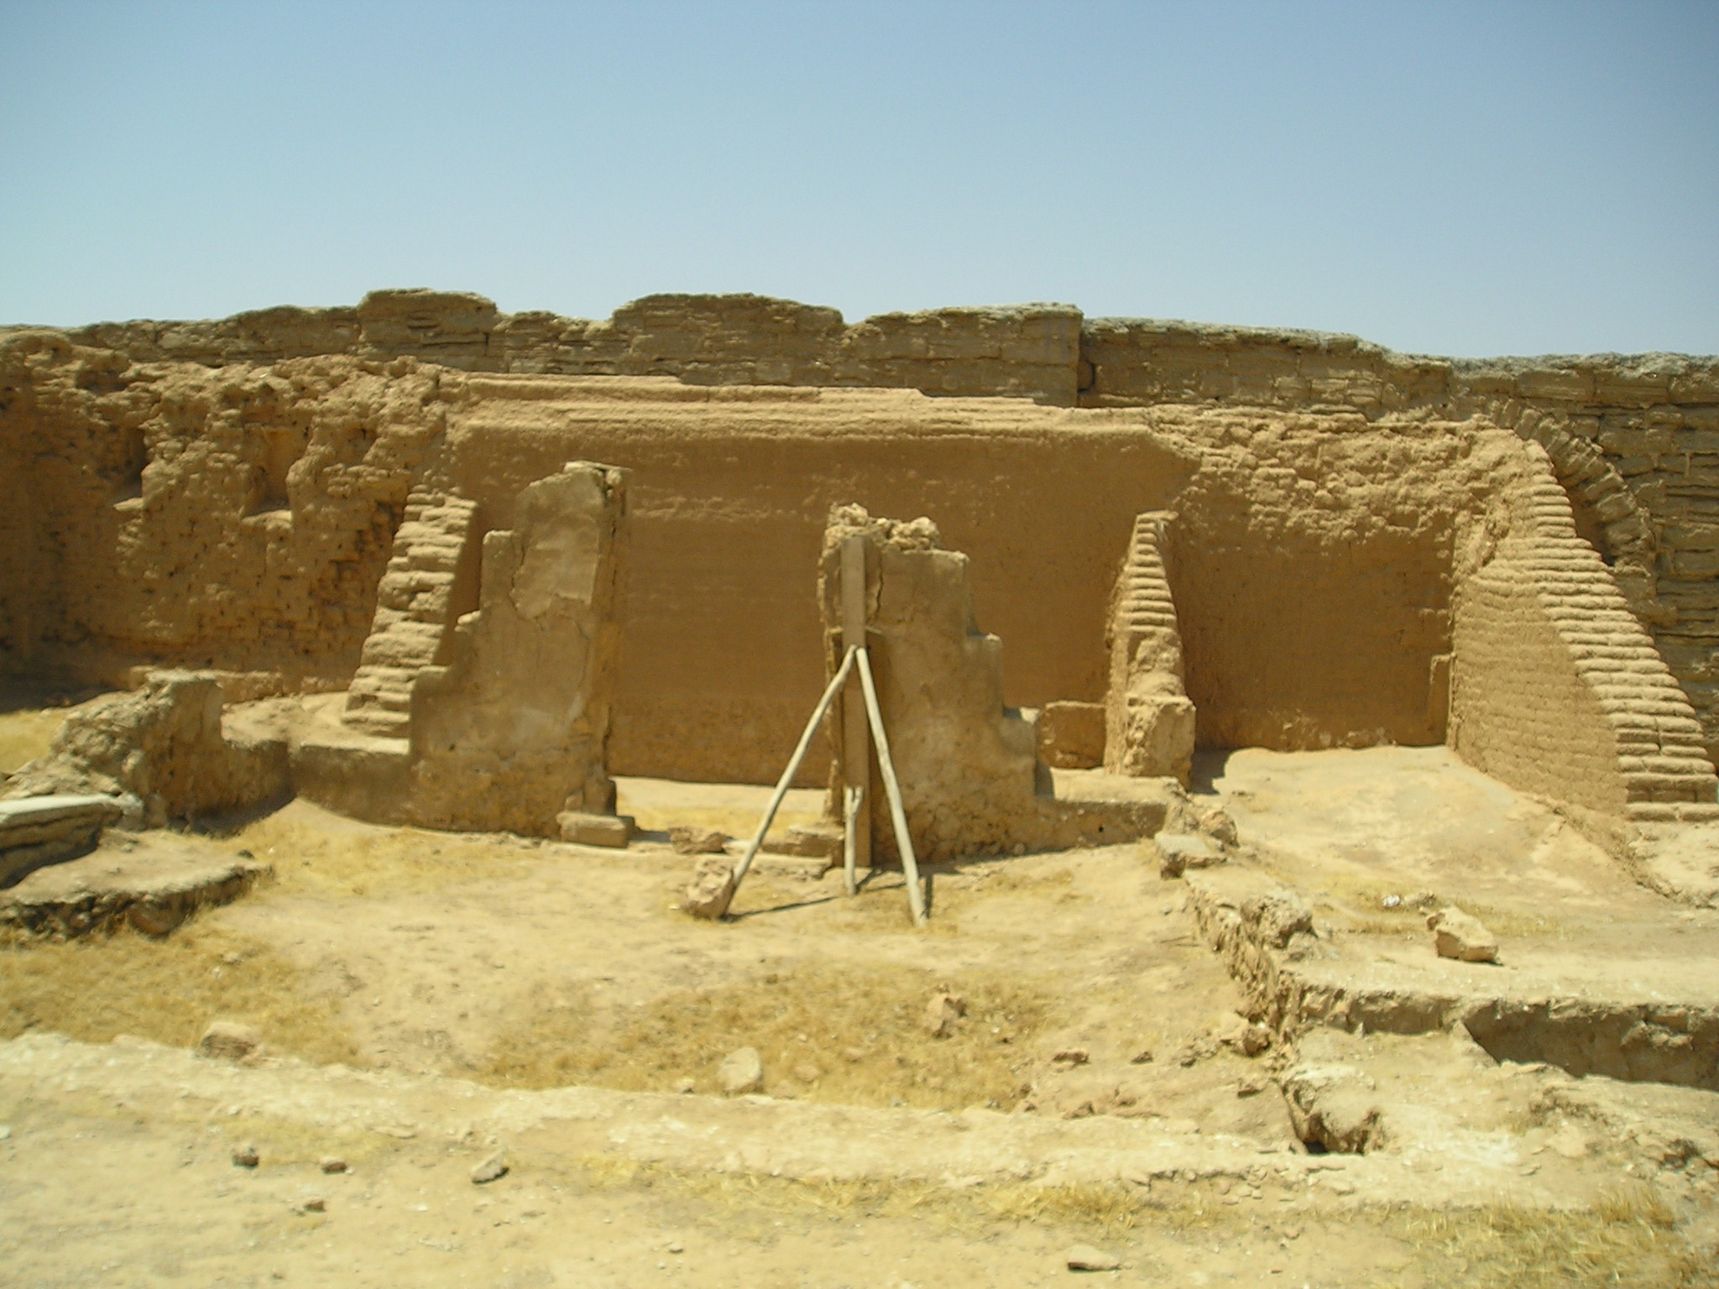
Figure 2 archaeological remains of the Church at Dura

- Women and the family in Greco-Roman culture

  - Women and the family in Greco-Roman culture

“The family is the association established by nature for the supply of men's everyday wants” (Aristotle, Politics, 1.2)

- Families.

  - centered on the paterfamilias, the “father/head of the family.”

  - Household = wife (though legally bound to father), unmarried children, and if he could afford it, slaves and sometimes freed slaves, and clients.

  - Families were generally very small

  - bigamy and polygamy was illegal.

- Women. (see Stark, The Rise of Christianity, ch. 5)

  - controlled by their husbands and were expected to obey them.

  - But by the first century, things were progressing quite a bit.

    - Plutarch (1st-2nd cent AD) even said: “every activity in a virtuous household is carried on by both parties in agreement, but discloses the husband’s leadership and preferences” (quoted in Jeffers, 142).

  - exposure of children

    - “Know that I am still in Alexandria…If you deliver a child before I come, if it is a boy keep it, if a girl discard it” (letter from husband to wife, author unknown, 1 B.C.)

    - exposure of children: leaving a newborn out in the open to die, be picked up, or eaten by wild animals

    - Legal, morally acceptable, and widely practiced by all social classes in the first century.

    - Nearly all exposed children were females

    - Seneca

    - Tacitus

  - Abortion

    - very common,

    - abortion was a major cause of premature death among women in the 1st century

    - methods:

    - Abortion was nevertheless encouraged among Roman leaders

      - Aristotle: “There must be a limit fixed to the procreation of offspring, and if any people have a child as a result of intercourse in contravention of these regulations, abortion must be practiced” (Politics 7.4.10)

    - Christianity

      - NT doesn’t explicitly address these, but early Christian teaching does:

        - “Thou shall not murder a child by abortion nor kill them when born” (Didache, 1st or 2nd cent)

        - “We have been taught that it is wicked to expose even newly-born children…[for] we would then be murderers” (Justin Martyr, 2nd cent)

        - “…we regard the very fetus in the womb as a created being, and therefore an object of Gods’ care…and [we do no] expose an infant, because those who expose them are chargeable with child-murder” (Athenagoras, late 2nd cent.)

    - Christianity held marriage in high-esteem. The marriage bond was sanctified

    - sexual promiscuity among single men was discouraged

  - Women and the family in early Christianity

- Jesus and Women

  - Luke 1-2: women are virtuous

  - Luke 8:1-3 supported Jesus ministry

  - healing and ministered to women frequently
    - John 4

    - Luke 10:28-32

  - appeared at his tomb

- Paul and Women

  - Priscilla and Aquila (Acts 18:1-2, 26; Rom 16:3-5)

  - Rom 16

  - Pheobe = deacon, maybe patron, probably the carrier and first reader of the letter to the Romans

  - 1 Tim 3:11 = women deacons

    - continued in the early Church

    - Clement of Alexandria refers to women deacons

    - Council of Chalcedon (AD 451) specifies criteria for “deaconesses.”

  - 1 Cor 11

  - many of the early Christian martyrs were women

  - Women in leadership?

    - 1 Tim 2

    - Elders (1 Tm 3; Titus 1)

    - no women in leadership office in NT

    - 1 Cor 14

- “house-hold codes” of Paul with those of Roman culture

- Ephesians 5:22-6:9

  - “Wives, submit to your husbands.”

    - Christian view of submission

      - 1 Cor 11:3

      - Phil 2:5-11

      - Eph 5:21

      - Sum: Christianity made submission a virtual and a means of gaining honor and glory

  - man’s position as head of the family is affirmed, but it is radically reconfigured.

  - Paul radicalizes this and commands husbands to love their wives with a self-sacrificial love.

- Slavery and Christianity

  - Introduction

- Statistics

  - 20% of Rome were slaves

- Overview (Fergeson, 56ff)

  - Slaves came from:

    - captives of war
    - sale of child or self to pay a debt
    - condemnation in law-court
    - birth to slave mother
    - purchase from slave market
    - kidnapping/piracy
    - child exposure

  - a slave was considered a “thing,” “living property” (Aristotle)

  - “the slave is a living tool and the tool a lifeless slave” (Aristotle)

  - slaves are “articulate instruments” (Varro)

  - slaves had no rights and were subject to the absolute power of its owner.

  - not all slave owners were bad, though. If he/she was good, the slave might actually enjoy a better life than a free-born peasant

- Ancient Slavery and Modern Slavery

  - Ancient slavery was not based on ethnicity, but status.

  - Ancient slavery often used slaves for highly skilled positions, not just manual labor.

    - esp. imperial slaves (Doctors, sculptors, scribes, etc.)

    - example: Marcus Antonius Felix (cf. Acts).

    - Aristocratic disdain for such upward mobility:

      - Felix “practiced every kind of cruelty and lust, wielding the power of a king with all the instincts of a slave” (Tacitus, Histories, 5.9).

  - Ancient slaves could earn their freedom through good service and saving up money

  - Slavery in the New Testament

- Christianity in the NT didn’t condemn slavery

- But it did adopt the very term of “slave” to refer to all humanity (1 Cor 7:22), even Christ (Phil 2; cf. John 13)

- all people have inherent value and worth

- Why didn’t the NT condemn the very practice of slavery? (Jeffers, 235)

  - Some types of slavery (paying off debts, etc.) would not have been inherently immoral

  - While Christian slave-owners are not commanded to free their slaves, they are exhorted to transform their relationship into one of brotherhood.

  - No major figure in the NT owned slaves

  - Paul often said that in Christ there is no difference between “slave and free” (1 Cor 12:13; Gal 3:28; Col 3:11).

“This would have sounded like utter nonsense to the average Roman, but it reveals a revolutionary definition of identity and status”

